–––A PROJECT REPORT

On

“AI-Enabled FinTech B2B Invoice Management Application”

Submitted to

KIIT Deemed to be University

In Partial Fulfilment of the Requirement for the Award of BACHELOR’S DEGREE IN INFORMATION TECHNOLOGY

BY

ROHIT GHOSH 1929038

UNDER THE GUIDANCE OF

ADITYA KUMARI, SHAILESH DAS
KIIT



SCHOOL OF COMPUTER ENGINEERING

KALINGA INSTITUTE OF INDUSTRIAL TECHNOLOGY

BHUBANESWAR, ODISHA - 751024

May 2020

A PROJECT REPORT

On

“AI-Enabled FinTech B2B Invoice Management Application”

Submitted to

KIIT Deemed to be University

In Partial Fulfilment of the Requirement for the Award of

BACHELOR’S DEGREE IN INFORMATION TECHNOLOGY

BY

ROHIT GHOSH

1929038

UNDER THE GUIDANCE OF

ADITYA KUMARI, SHAILESH DAS
KIIT

SCHOOL OF COMPUTER ENGINEERING

KALINGA INSTITUTE OF INDUSTRIAL TECHNOLOGY

BHUBANESWAE, ODISHA -751024

May 2022

KIIT Deemed to be University

School of Computer Engineering
Bhubaneswar, ODISHA 751024

CERTIFICATE

This is to certify that the project entitled

“AI-Enabled FinTech B2B Invoice Management Application“

Submitted by

ROHIT GHOSH 1929038
Is a record of bonafide work carried out by them, in the partial fulfilment of the requirement for the award of Degree of Bachelor of Engineering (computer science & Engineering OR Information Technology) at KIIT Deemed to be University, Bhubaneswar. This work is done during the years 2022-2023, under our guidance.

Date: - 14/04/2022

(ADITYA KUMARI, SHAILESH DAS)
AI-Enabled FinTech B2B Invoice Management Application

Mentor Acknowledgments

I am profoundly grateful to ADITYA KUMARI, SHAILESH DAS of KIIT for their expert guidance and continuous encouragement throughout to see that this project rights its target from its commencement to its completion.

ROHIT GHOSH

ABSTRACT

The B2B world operates differently from the B2C or C2C world. Businesses work with other businesses on credit. When a buyer business orders goods from the seller business, the seller business issues an invoice for the same. This invoice for the goods contains various information like the details of the goods purchased and when they should be paid. This is known in accounting terminology as “Accounts Receivable”.

“Accounts Receivable represents money owed by entities to the firm on the sale of products or services on credit. In most business entities, accounts receivable is typically executed by generating an invoice and either mailing or electronically delivering it to the customer, who must pay it within an established timeframe, called credit terms or payment terms.”

The main aim of the project is to build an AI enabled prediction of the payment date of the invoice based upon payment terms, invoice id, past payment details. The prediction is handled by applying regression methods in Machine Learning via python libraries like Scikit-learn, while the backend (updation of the actual database) is done via Java Servlet, JDBC and MySQL. ReactJS covers the front end. Flask is also used in order to use python script via the front end for the prediction.

Contents

1 | Introduction |  | 1
2 | Basic Concepts |  | 2
 | 2.1 | Machine Learning | 2
- Pandas
- Numpy
- Matplotlib
- Scikit-learn
 | 2.2 | Front End:-  - ReactJS | 2
 | 2.3 | Back End:-  - JDBC  - Java  - Servlet | 3
- 3 | Problem Statement
 | 3.1 | Project Planning........................... | 4
 | 3.2 | Project Analysis........................... | 4
 | 3.3 | System Design ………………….. | 5
4 | Project Diagram
 | 4.1 | Client Server Architecture | 11
5 | Limitations
 | 5.1 | Limitations | 12
 | 5.2 | Future Scope | 12
References |  |  | 13
Individual Contribution |  |  | 14

List of Images
3.3.2.1.1 Add Modal 5
3.3.2.1.2 Full Screen Add Modal 6
3.3.2.2.1 Edit Modal 6
3.3.2.2.2 Full Screen Add Modal 7
3.3.2.3.1 Delete Modal 7
3.3.2.3.2 Full Screen Delete Modal 7
3.3.2.4 Predict Button 8
3.3.2.5.1 Advanced Search Modal 8
3.3.2.5.2 Full Screen Advanced Search Modal 8
3.3.2.6 Search Bar 9
3.3.2.7 Grid Layout 9

AI-ENABLED FINTECH B2B INVOICE MANAGEMENT

Chapter 1

Introduction

In the satisfactory world, the consumer enterprise agency needs to pay lower back within the stipulated time (i.e. the Payment Term). However, in the actual world, the consumer enterprise agency seldom will pay in the required time frame, and that is where the Account Receivables Department comes into the picture.
Every enterprise agency includes a devoted Account receivables Department to collect and tune the fee of invoices. It includes an Account receivables organization this is accountable for:
• Collecting bills for a customer’s invoices.
• Sending reminders and follow-ups to the clients for bills to be made.
• Looking after the complete machine of having the coins inflow.
• Help the business enterprise receives a price for the products and services supplied.

As the project, I constructed a web application to assist the people on foot within the Accounts Receivable departments with their everyday activities constructed an internet software program application in which the customers within s the Account Receivable branch can:
• View the bill facts from numerous buyers.
• See numerous fields. Attributes of the bill(s) from any specific consumer.
• Perform Data Pre-processing at the bill date.
• Get account-degree analytics without trouble and visualize interpreting facts-EDA and Feature Engineering.
• Get a prediction of the time frame within which the bill will be paid.

School of Computer Engineering, KIIT, BBSR 1

AI-ENABLED FINTECH B2B INVOICE MANAGEMENT

Chapter 2

Basic Concepts

  - Machine Learning:-
- Pandas: - The pandas package deal is the maximum critical device for Machine Learning programs. It is the spine of each data technology project. Pandas can extract /discover a dataset saved in a CSV (Comma Separated Value) format. It will extract the facts right into a DataFrame (a table) and may make get the result of the average, median mode of each column. Correlation and Covariance also can be observed in the usage of the Pandas library.
- Numpy: - Numpy is the essential package deal for clinical computing in Python. It is a Python library that provides a multidimensional array object, various derived objects (such as masked arrays and matrices), and an assortment of routines for fast operations on arrays, including mathematical, logical, shape manipulation, sorting, and much more.
- Matplotlib:-Matplotlib is a cross-platform, data visualization and graphical library for Python and its numerical extension Numpy. As such, it offers a viable open-source alternative to MATLAB.
- Scikit-learn: - It is the most useful and robust Library for machine learning in Python. It provides a selection of efficient tools for machine learning and statistics including classification, regression clustering, and dimensionality reduction via a consistence interface in Python.

  - Front End:-
- ReactJs:-React is a JavaScript-based UI development library. Facebook and an open-source developer community run it. Although React is a library rather than a language, it is widely used in web development.

School of Computer Engineering, KIIT, BBSR 2
AI-ENABLED FINTECH B2B INVOICE MANAGEMENT

  - : - Back End:-

- JDBC: - Java Database Connectivity (JDBC) is an application programming interface (API) for the programming language Java, which defines how a client may access a database. It is a Java-based data access technology used for Java database connectivity.
- Java: - Java is a high-level, class-based, object-oriented programming language that is designed to have as few implementation dependencies as possible.
- Servlets: - A Jakarta Servlet is a Java software component that extends the capabilities of a server. Although servlets can respond to many types of requests, they are most commonly used to implement web containers for hosting web applications on web servers and thus qualify as a server-side servlet web API.
- MySQL: - It is an open-source relational database management system.
- Flask:-Flask is a micro web framework written in Python. It is classified as a micro framework because it does not require particular tools or libraries. It has no database abstraction layer, form validation, or any other components where pre-existing third-party libraries provide common functions.

School of Computer Engineering, KIIT, BBSR 3

AI-ENABLED FINTECH B2B INVOICE MANAGEMENT

Chapter 3

Problem Statement:-

The objective of the Web Application Development Project is:
- To build a Full-stack Invoice Management Application using ReactJS, JDBC, Java, and Servlets.
- Build a responsive Receivables Dashboard.
- Visualize Data in the form of grids.
- Perform Searching operations on the invoices.
- Add & Edit data in the editable fields of the grid.
- Delete data of selected rows in predefined templates.
- Prediction of the delay in payment of Invoice.

3.1 Project Planning
A simple plan is to be followed when developing this project. The end system must be robust and engaging enough to have the user have no problem in navigating the UI (User Interface) and have no problem in getting the results.

The plan is to use ReactJS as the Front End due to easy and ready to use “Hooks” to help develop the UI and the simplicity of Java language based Servlet and JDBC to handle the backend operations which can be modified according to the user on their own.

3.2 Project Analysis

After the successful deployment of the project, the user can freely use the functions that are created i.e. Add, Edit, Delete, and Predict Search.

School of Computer Engineering, KIIT, BBSR 4

AI-ENABLED FINTECH B2B INVOICE MANAGEMENT

  - System Design:-
There are 2 sections that are used to display data for the user:-
- Header:-
          - First Section is the header which comprises the logos, which can be the user company logo or any other logo which can be implemented.
- The second section consists of Predict, Advance Search, Analytics View, Add, Delete & Edit, and Search bar.
- Add Button :-
- It is used for adding the new field values to the grid.
- After clicking on the Add button, a pop-up window will appear with all the fields for which values need to be ad along with a cancel and an Add button.
- The user would be able to type in the values, except for the date values where there would be a calendar view from where the user will be able to select the required date, month and year.
- If the user tries to click on add before all the mandatory fields are filled, the user will not be able to add.

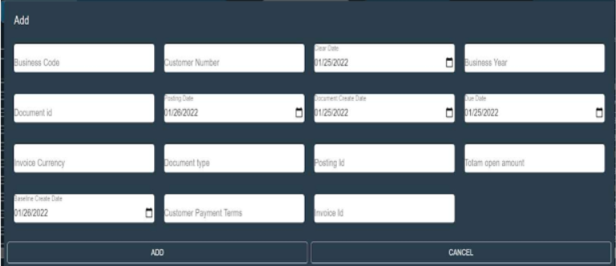
3.3.2.1.1 Add Modal

School of Computer Engineering, KIIT, BBSR 5

AI-ENABLED FINTECH B2B INVOICE MANAGEMENT

Full Screen View:-
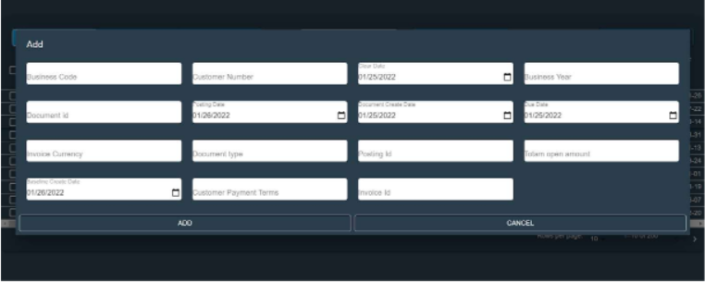
3.3.2.1.2 Full Screen Add Modal

- Edit Button :-
- It is used for editing the editable field values in the grid.
- A user would be able to select a row and then click on the Edit button.
- The fields which can be edited are the Invoice Currency and Customer Payment Terms fields.
- On clicking the Edit button, a popup will open up. The user would be able to edit the existing value.
- The popup will also have Edit, Cancel as shown in the UI below.

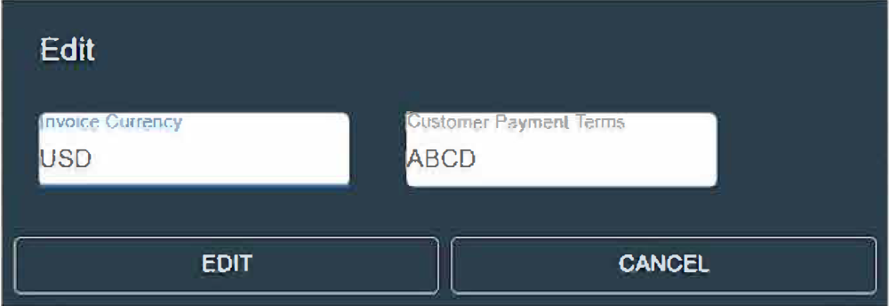
3.3.2.2.1 Edit Modal

School of Computer Engineering, KIIT, BBSR 6

AI-ENABLED FINTECH B2B INVOICE MANAGEMENT

Full Screen View:-
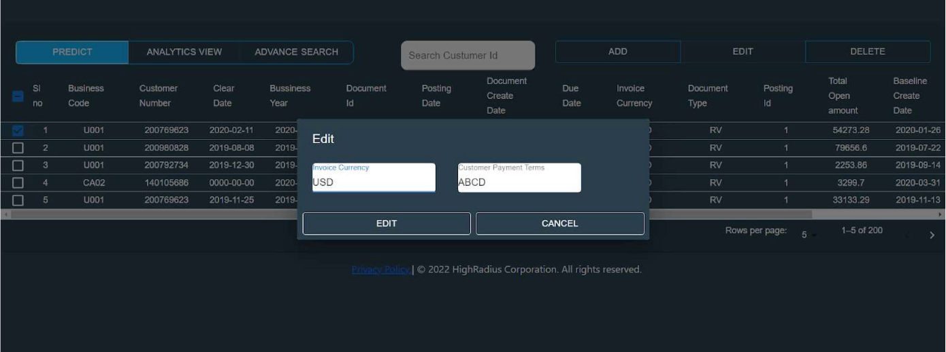
3.3.2.2.2 Full Screen Edit Modal

- Delete Button :-
- Clicking on the delete button will allow the user to delete records from the grid.
- A pop-up will be displayed on clicking delete to confirm that the user wants to delete the selected records permanently.
- Once the user clicks on the delete button, the row(s) should be removed from the grid in the UI and should remain persistent.

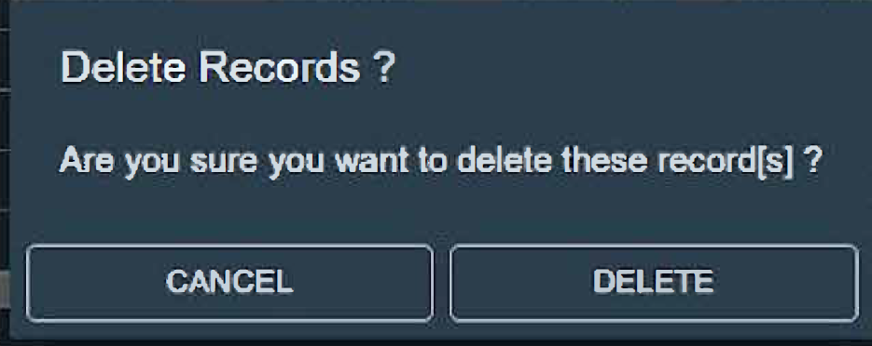
3.3.2.3.1 Delete Modal

Full Screen View:-
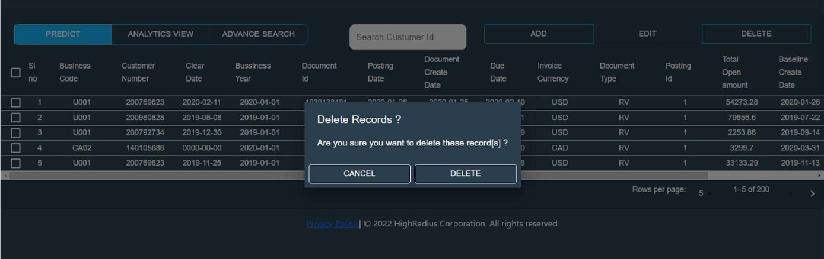
        - Full Screen Delete Modal

School of Computer Engineering, KIIT, BBSR 7

AI-ENABLED FINTECH B2B INVOICE MANAGEMENT

- Predict Button :
- Users would be able to predict the payment date of selected Invoices with the help of the Predict Button.
- Clicking on the button will populate the Aging Buckets column on the UI with predicted dates.
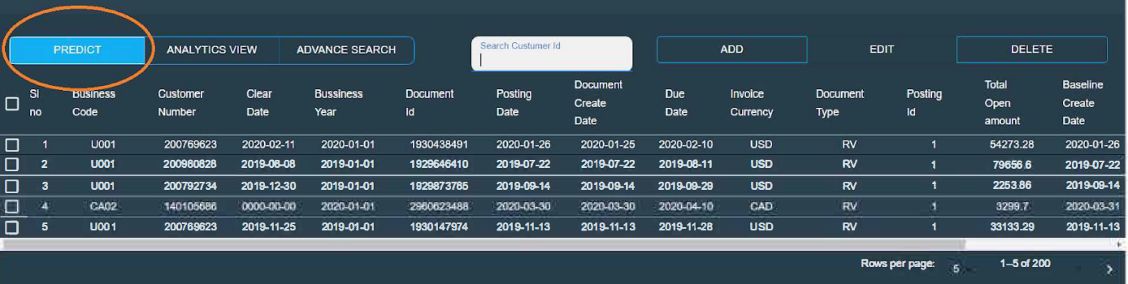
3.3.2.4 Predict Button
- Advanced Search Button:-
- Clicking on this button will help the user to perform an advanced search on the data based on the following four fields:
            - Document Id
            - Customer Number
            - Invoice Number
            - Business Year
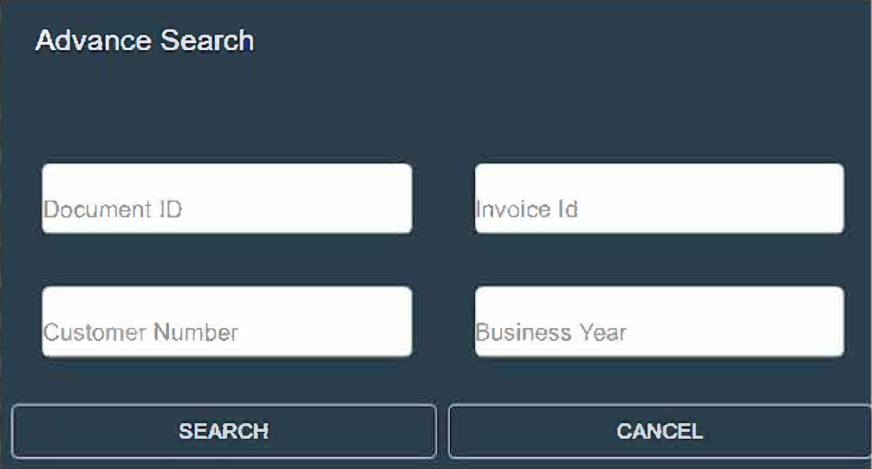
3.3.2.5.1 Advanced Search Modal
Full Screen View:-
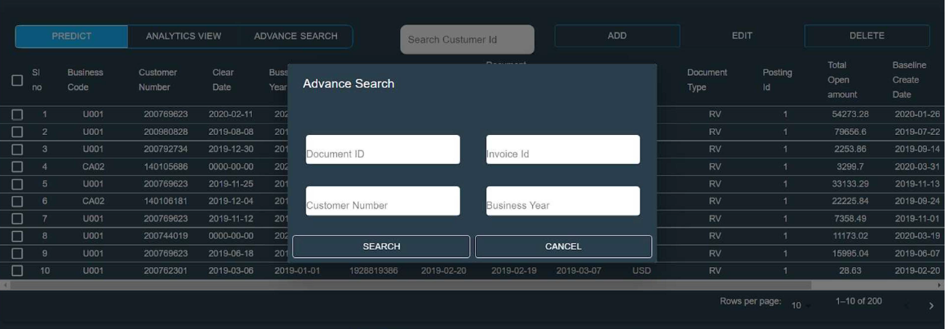
3.3.2.5.2 Full Screen Advanced Search Modal

School of Computer Engineering, KIIT, BBSR 8

AI-ENABLED FINTECH B2B INVOICE MANAGEMENT

- Search Bar:-
- Users would be able to search for a customer by typing the Customer Id in the Search Bar.
- Input is restricted to only numbers.
- Can even search for partial customer id no.
3.3.2.6 Search Bar

- Grid Panel Section:-
This section displays all the different column name headers and a Select All and Deselect All functionality.
Following are the columns to be displayed in the UI:
1. Sl_no
2. Business_code
3. Cust_number
4. Clear_date
5. Buisness_year
6. Doc_id
7. Posting_date
8. Document_create_date
9. Due_in_date
10. Invoice_currency
11. Document type
12. Posting_id
13. Total_open_amount
14. Baseline_create_date
15. Cust_payment_terms
16. Invoice_id
The Grid consists of Grid Rows that contains the required data that is loaded from the database stored in MySQL. On a single page, only 10 invoices’ data is displayed. Users can select single or multiple rows.

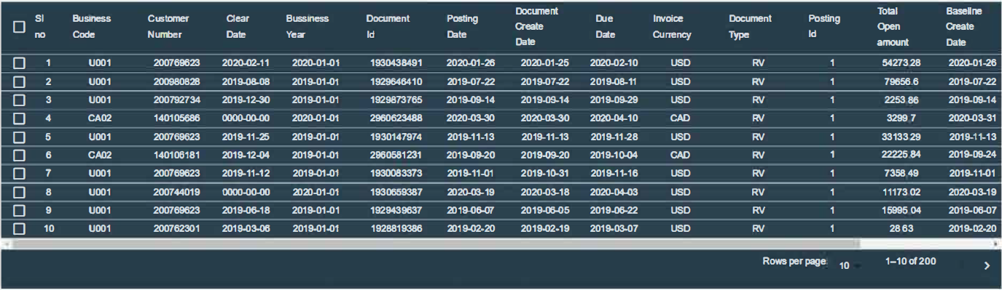
3.3.2.7 Grid Layout

School of Computer Engineering, KIIT, BBSR 9

AI-ENABLED FINTECH B2B INVOICE MANAGEMENT

Sorting:
- Sorting should be performed on all the columns.
- Clicking on the column headers will sort the values of the whole grid.
- First Click- Ascending
- Second Click- Descending
- Third Click – Normal
- Column Headers will have arrow symbol near the column name to indicate in what way they are sorted.

Footer:
The Grid consists of the Footer which will have the following 3 parts:
- “Viewing <page count> of<total page count> text on left. It shows the total number of pages that have given number of rows per page.
- On the right, Pagination arrows with a dropdown displaying rows per page. The previous/back button will be disabled when the user is in the first page. The next button will be disabled similarly if the user is on the last page.
- Desired company logo in the centre.

AI support for the prediction of payment date:
- As part of this project, I have to predict the payment date of each invoice.
- In order to achieve this, the Predict runs a flask API of python file which will predict the payment date of each selected rows.
- The prediction takes place using Machine learning concepts used in Python. The database is first converted into a CSV file with which a model with least mean squared error and high r2 score is selected.
- The model which is selected dumped using joblib library and called by the flask API.
- The selected rows are converted into CSV from which the Flask can use it to predict the payment date.

School of Computer Engineering, KIIT, BBSR 10

AI-ENABLED FINTECH B2B INVOICE MANAGEMENT

Chapter 4

4.1 Project Diagram:-
(Client Server Architecture)

WEB BROWSER

FUNCTIONALITY

RESPECTIVE SERVLET OF FUNCTIONALITY

MY SQL DATABASE

School of Computer Engineering, KIIT, BBSR 11

AI-ENABLED FINTECH B2B INVOICE MANAGEMENT

Chapter 5

5.1 Limitations:-
The limitations of this project are minor but easily fixable. They are as follows:-

- Response Time: - Although the majority of the servers of this project are hosted via localhost of the user’s computer, the different ports give a long response time between the front end and the back end of the project. The flask API is hosted at http://127.0.0.1:5000, the ReactJS frontend is hosted at http://localhost:3000, and the Servlets via which the SQL database is used is hosted at http://localhost:8080 and the SQL database itself via http://localhost:3306 . If the computer is slow, the response time may get longer.
- Compatibility: The Node js version on which ReactJS is run upon is 17.4.2, while the Java Development Kit (JDK) is 17.0.2, while Flask is 2.1.1. The backwards and forwards compatibility of the tools/software used has not been tested and may hamper operations if same configurations are not made.

5.2 Future Scope:-
Future Scope of this web application is vast. It can also be used in a hospital administrative system where each patient could have unique number and a common symptoms of disease. The discharge date and the medicine followed during each case could be of useful record to predict the total cost of the hospital services used.

School of Computer Engineering, KIIT, BBSR 12

AI-ENABLED FINTECH B2B INVOICE MANAGEMENT

References

[1] https://reactjs.org

[2] https://www.tutorialspoint.com/servlets/index.htm

[3] https://www.ibm.com/docs/en/informix-servers/12.10?topic=started-what-is-jdbc\

[4] https://www.fullstackpython.com/flask.html

School of Computer Engineering, KIIT, BBSR 13

AI-ENABLED FINTECH B2B INVOICE MANAGEMENT

SAMPLE INDIVIDUAL CONTRIBUTION REPORT:

AI-ENABLED FINTECH B2B INVOICE MANAGEMENT

ROHIT GHOSH
1929038

Abstract: The main aim of the project is to build an AI enabled prediction of the payment date of the invoice based upon payment terms, invoice id, past payment details. The prediction is handled by applying regression methods in Machine Learning via python libraries like Scikit-learn, while the backend (updation of the actual database) is done via Java Servlet, JDBC and MySQL. ReactJS covers the front end. Flask is also used in order to use python script via the front end for the prediction.

Individual contribution and findings: The full role of making and developing the project was upon me, Rohit Ghosh (Roll NO 1929038).
Individual contribution to project report preparation: The project report was also made by Rohit Ghosh.

Individual contribution for object presentation and demonstration: The demonstration of the project was also handled by Rohit Ghosh.

Full Signature of Project Mentor: Full signature of the student:


……………………………. ……………………………..

School of Computer Engineering, KIIT, BBSR 14

